Week 8 Report

The data set I will be going over is Rice, P. C., & Paterson, A. L. (1985).Cave art and bones: exploring theinterrelationships. American Anthropologist, 87(1), 94-100.
This data has (n=50) observations. This data also has 4 variables, including region, bone abundance, bone art count , and Taxa. Region meaning where the fauna was located and found. Bone abundance meaning how much of a certain type of faunal remains from a certain anminal. Bone art meaning the quantity of the bone that was used or created into pieces of art of each type of remains. Taxa meaning the type of faunal remains.
Tabel One: (Counts)
TAXA | BoneArt_Count | Bone Abundance
BOVINES | 386 | 223
DEER | 79 | 150
HORSE | 297 | 266
IBEX | 97 | 54
REINDEER | 70 | 289

Taxa Tables:
Tabel One: (Counts)
TAXA | BoneArt_Count | Bone Abundance
BOVINES | 38 | 28
 | 31 | 18
 | 33 | 21
 | 27 | 21
 | 9 | 18
 | 32 | 22
 | 83 | 21
 | 32 | 22
 | 55 | 30
 | 46 | 22
TAXA | BoneArt_Count | Bone Abundance
DEER | 6 | 13
 | 12 | 19
 | 1 | 3
 | 7 | 11
 | 24 | 21
 | 11 | 22
 | 0 | 15
 | 8 | 19
 | 7 | 11
 | 3 | 16
TAXA | BoneArt_Count | Bone Abundance
HORSE | 24 | 32
 | 38 | 23
 | 48 | 35
 | 40 | 25
 | 18 | 28
 | 21 | 25
 | 17 | 26
 | 36 | 27
 | 23 | 27
 | 32 | 18
TAXA | BoneArt_Count | Bone Abundance
IBEX | 14 | 2
 | 15 | 7
 | 0 | 0
 | 6 | 5
 | 24 | 9
 | 11 | 5
 | 0 | 8
 | 11 | 4
 | 6 | 1
 | 10 | 13
TAXA | BoneArt_Count | Bone Abundance
REINDEER | 4 | 21
 | 0 | 30
 | 18 | 42
 | 13 | 34
 | 3 | 24
 | 4 | 19
 | 0 | 29
 | 11 | 28
 | 7 | 31
 | 10 | 31

Graphs: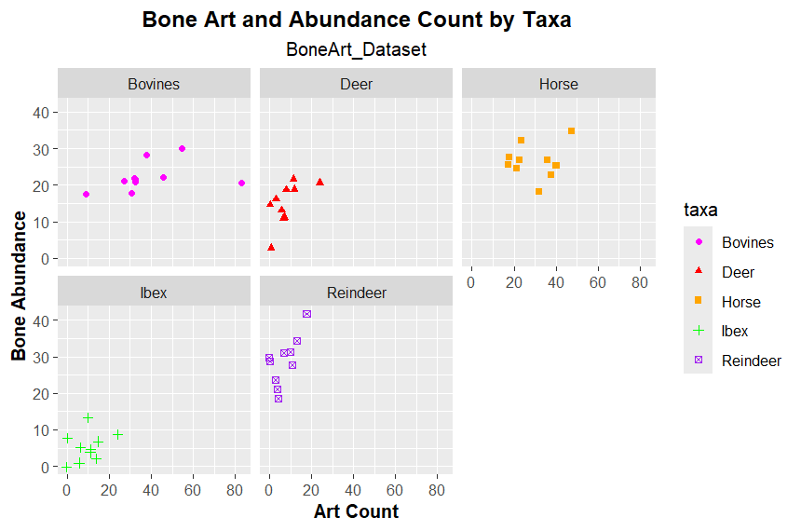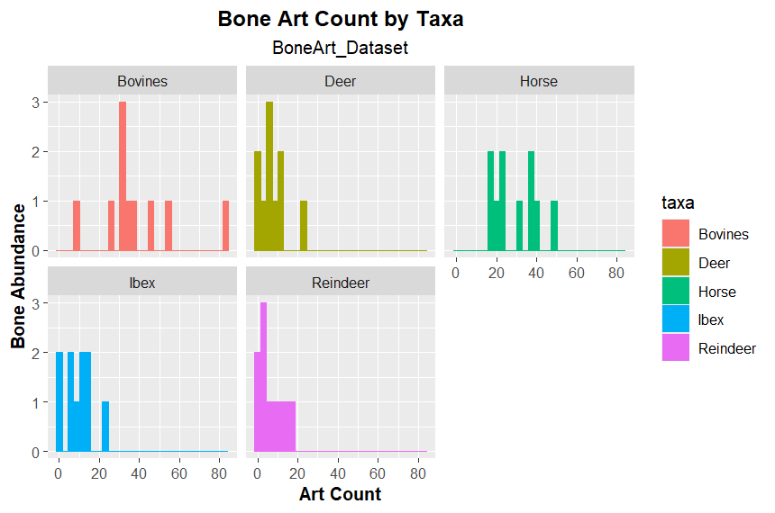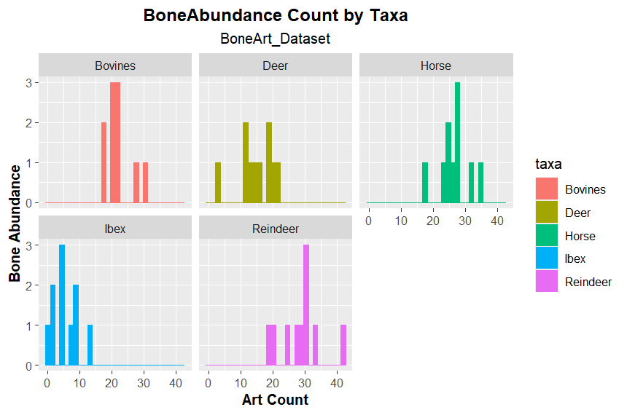:
Questions:
- What is the relationship between amounts of art and amounts of animal bone at these Palaeolithic sites?
The relationship inbetween the amount of art and the amounts of animal boen at all of these palolithic sites are a positive correlation of the two with the correlation amount being 0.357443 menaing any amount of bone from faunal remains that is found from this period is signifcatly correlated with bone art and the abundance of bones.

- How does this relationship vary for specific types of animal?
These relationships varies typically in a positive manner where the Bovines results where 0.3646652 , the results for deer where 0.6295011, the results for horse where 0.1397397, the results for Ibex where 0.3486233 , and the Reindeer results where 0.6889846 . All of theses correlation test results where positive where the highest positive correlation was the Reindeer with art and abundance correlation and the lowest positive correlation was the horses correlation even though it was still positive.

- What hypotheses about the purpose of cave art are supported by these relationships?
My hypotheses where that paleolithic pepole highly valued reindeer and deer remains through art from there bones rather than the other faunal remains. Another Hypothosis is that even though there is a greater abundance of horse bones than the rest of the remains of other taxa there where more likely hunted more often than the other taxa and was seen as less valuable in a spitural or artistic manners with bone materials.

